Olan, Jayvee T.

Part 1 — Settings, Shared Variables and apiFetch()
setup-01-api-running: part-01-settings-apifetch

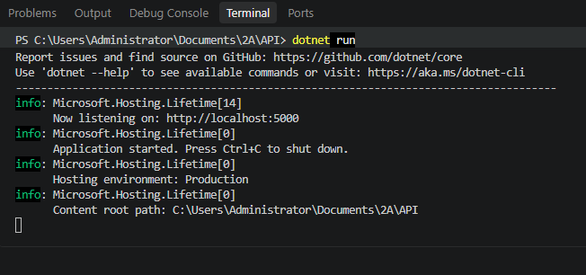

setup-02-api-books-json: part-01-settings-apifetch
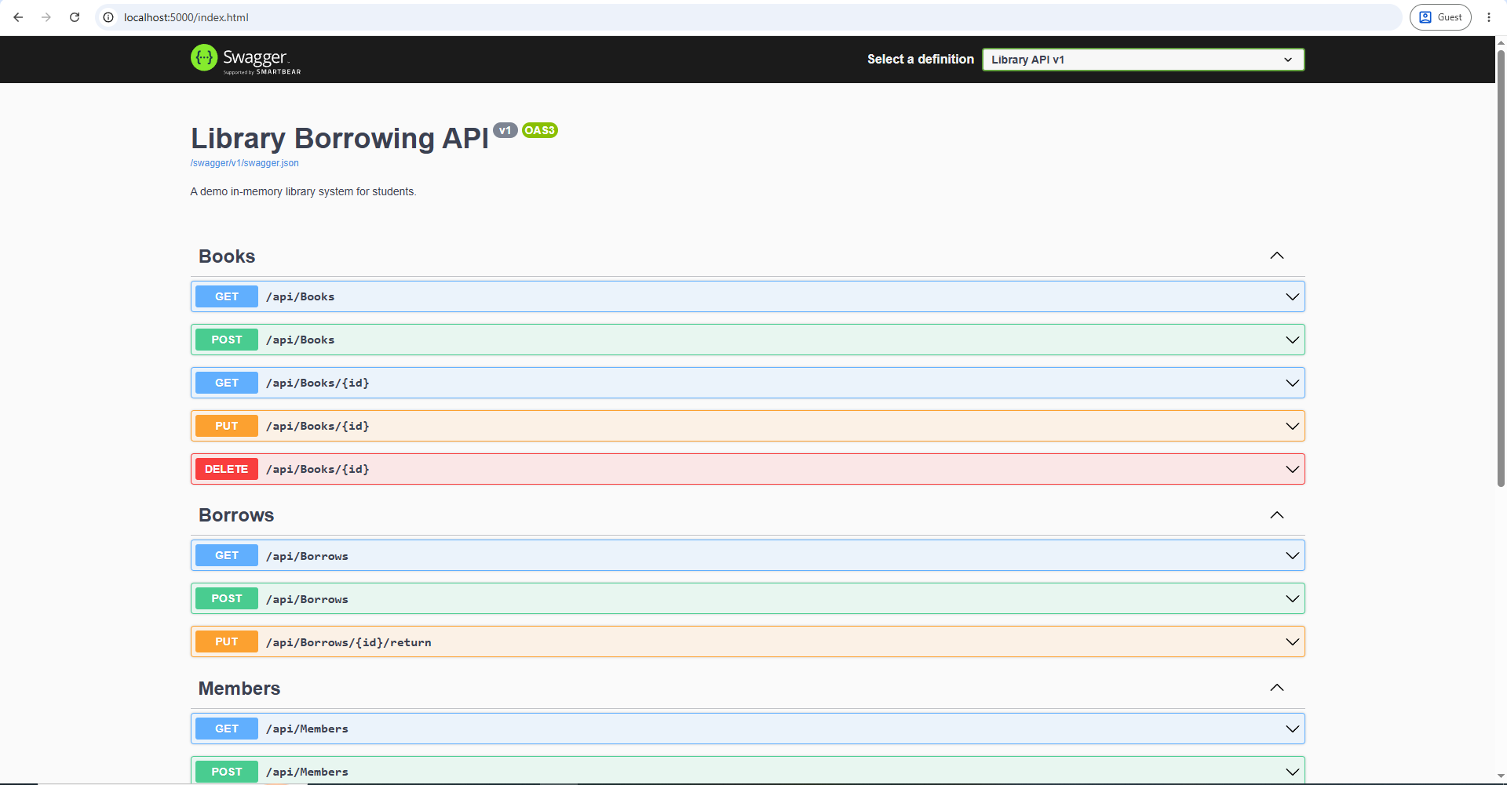

Part 2 — Toast Messages

part-02-showtoast
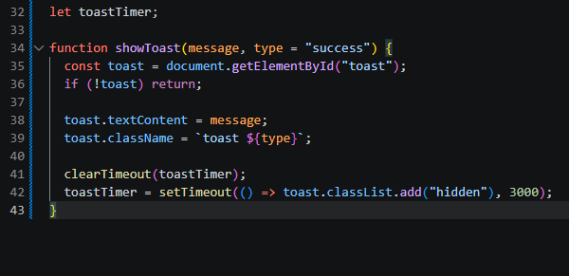

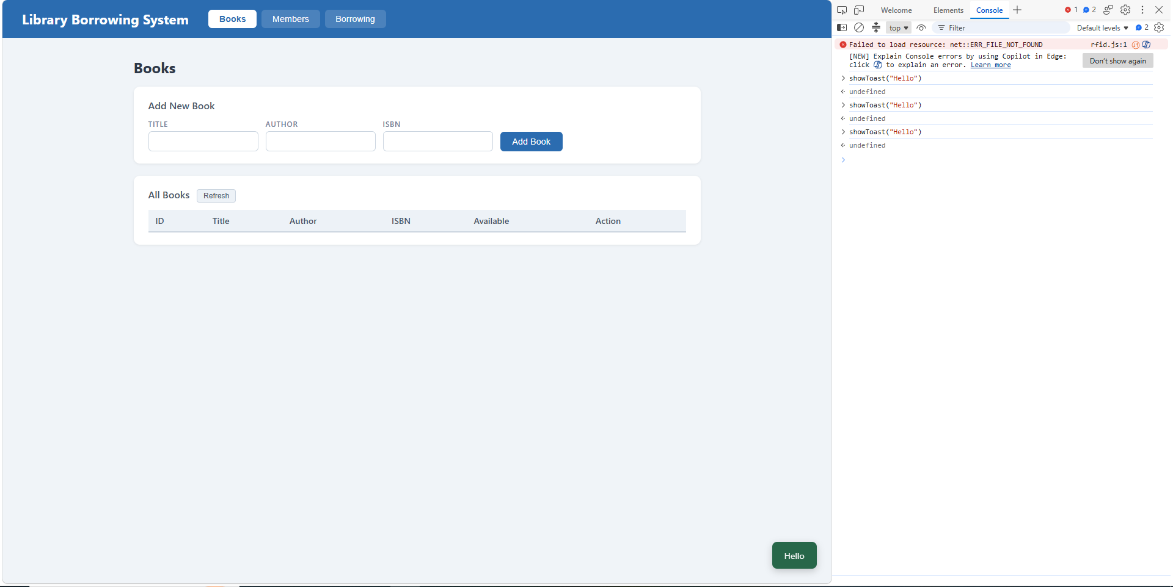

Part 3 — Caches and Find Member by RFID

part-03-caches
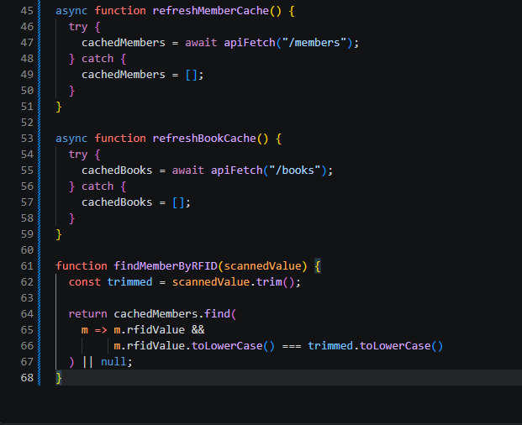
QUICK CHECK
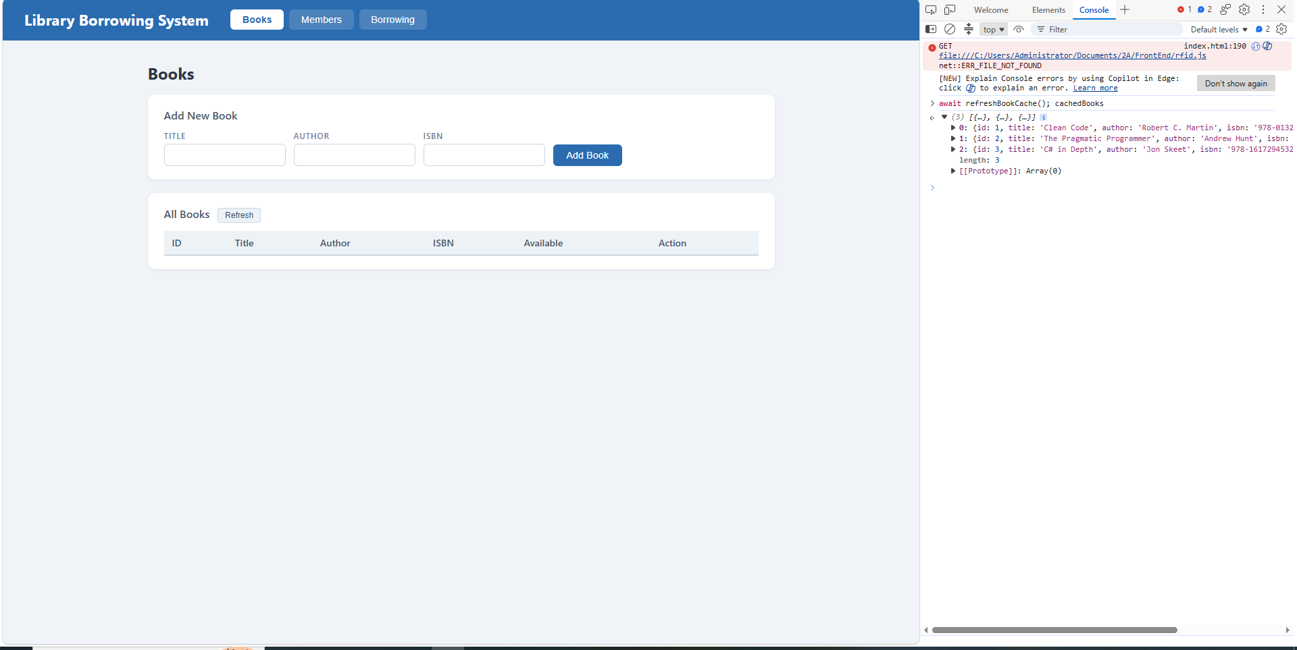

Part 4 — Tabs and Refresh Buttons

Part-04-tabs-refresh
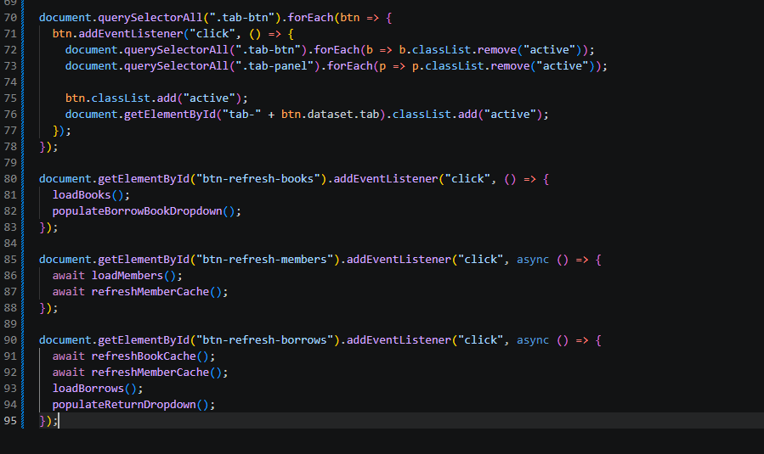
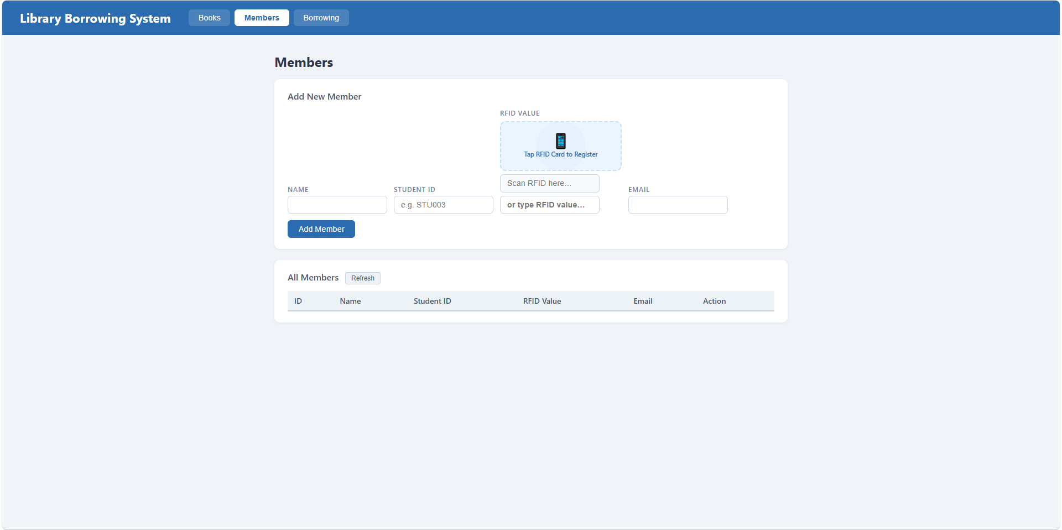

Part 5 — Load Books into Table

part-05-loadbooks

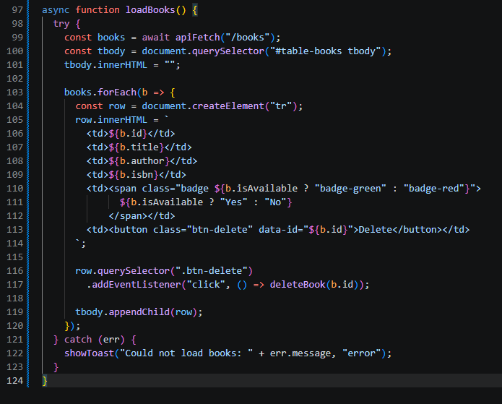

Part 6 — Delete Book

part-06-deletebook
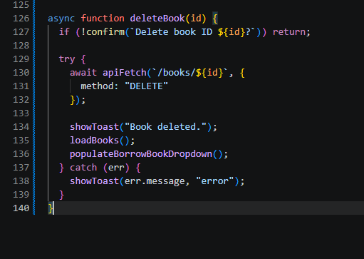

Part 7 — Add Book

part-07-addbook
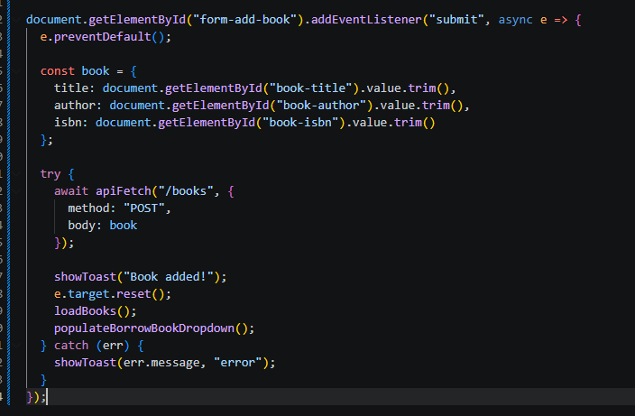

Part 8 — Load Members into Table

Part-08-loadmembers
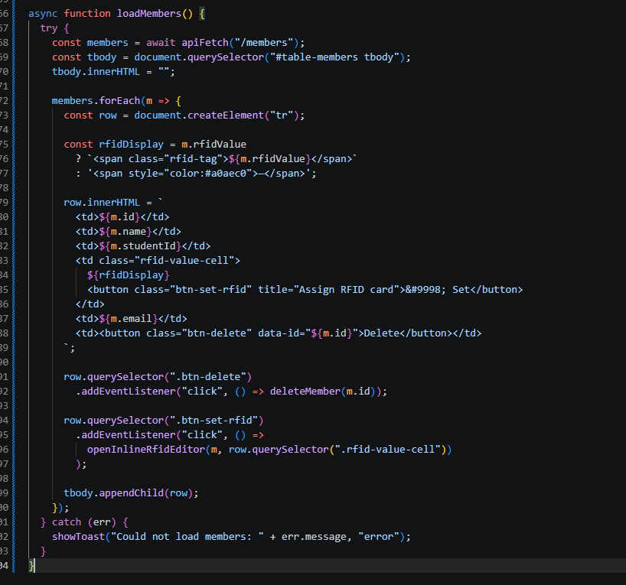

Part 9 — Delete Member

Part-09-deletemember
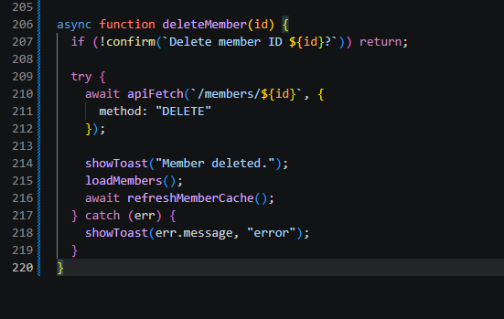

Part 10 — Add Member with RFID

Part-10-addmember
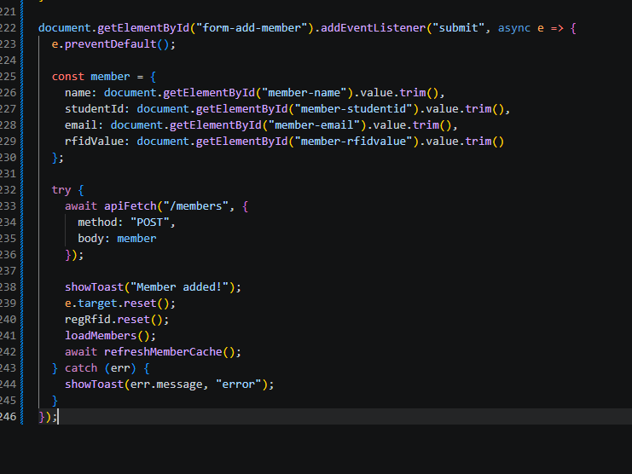

Part 11 — Inline RFID Editor and Update Member RFID

Part-11-inline-rfid-editor
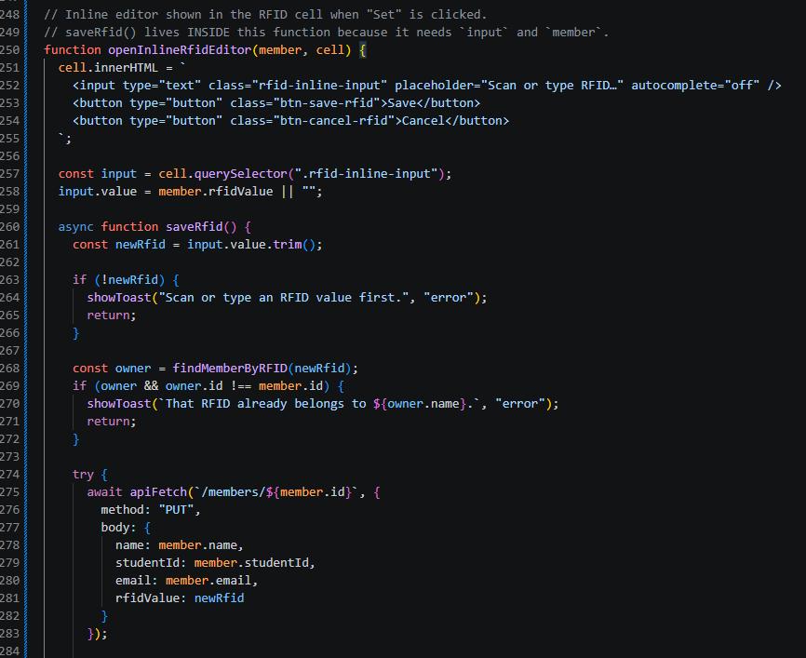

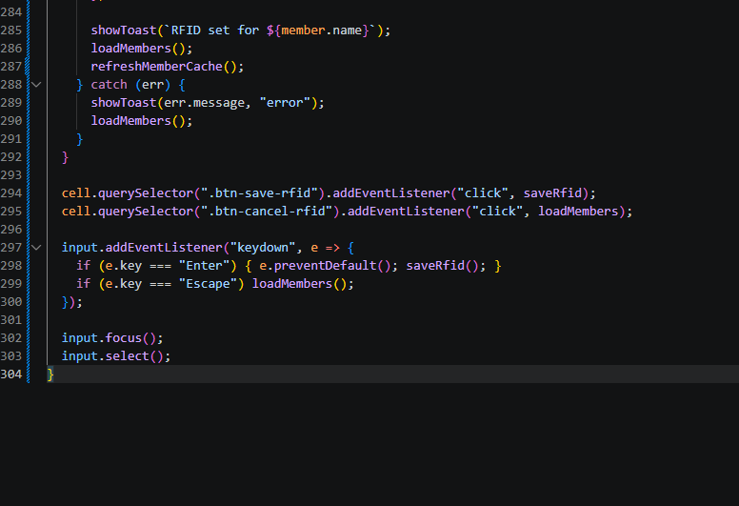

Part 12 — RFID Widgets (Borrow, Register, Return)

part-12a-rfid-widget-builder
1.
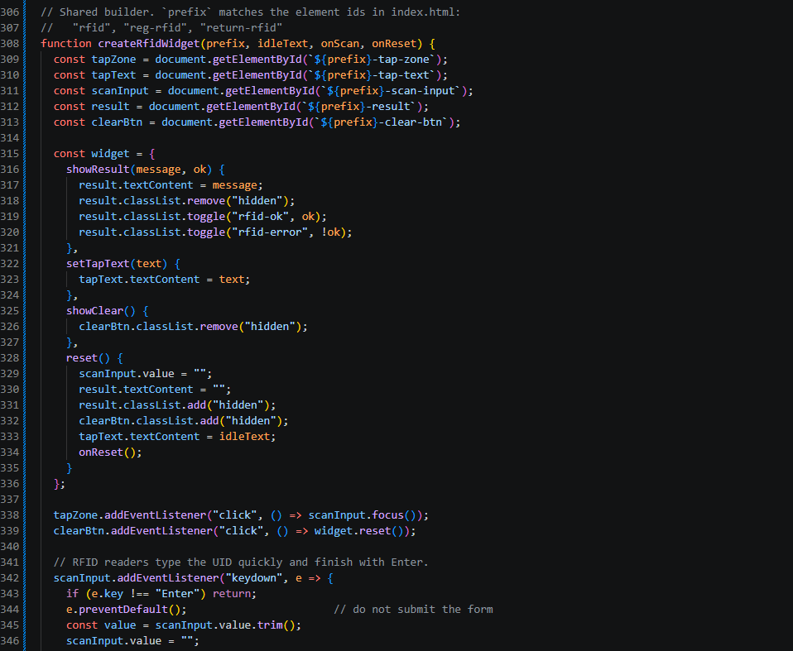

2.
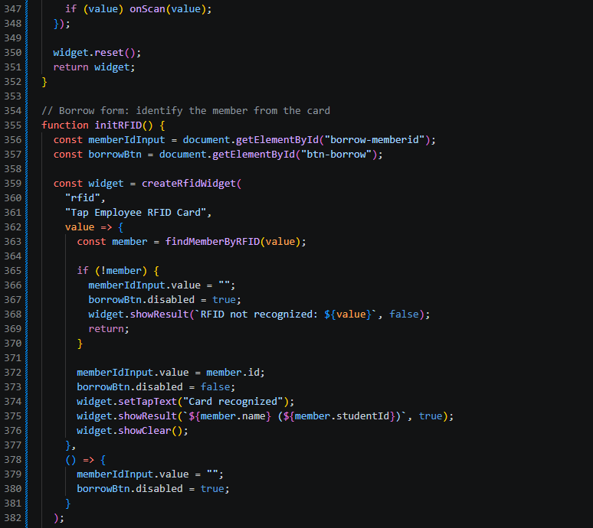

3.
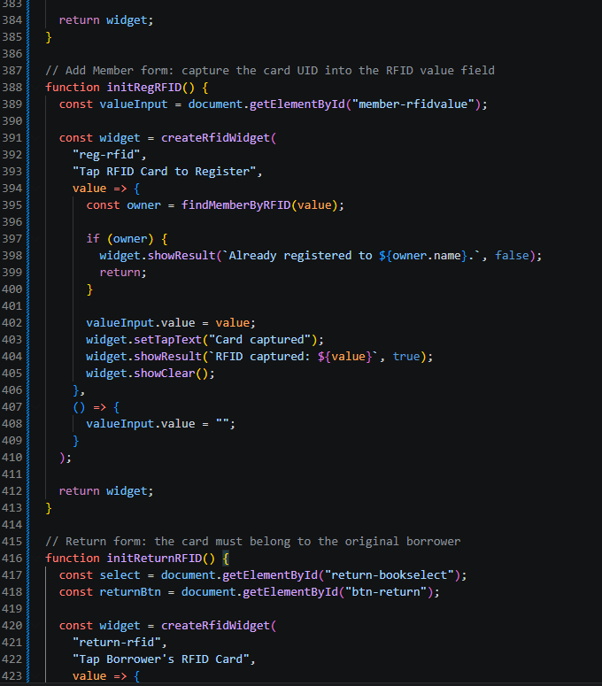

4.
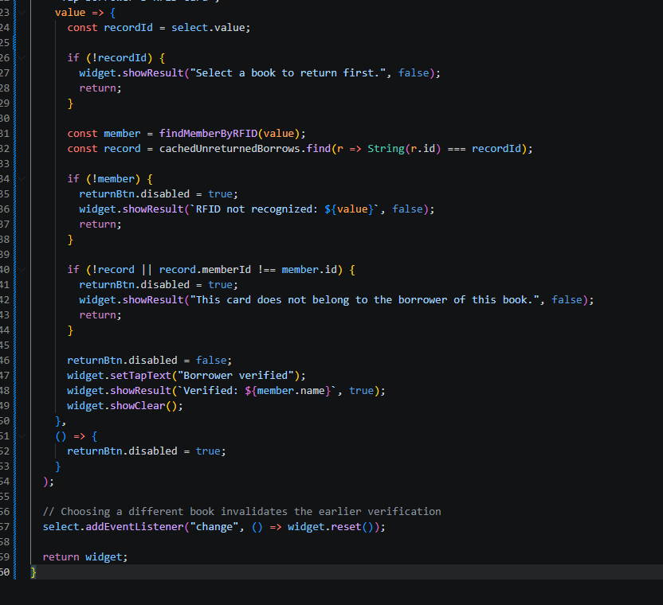

Part 13 — Populate Borrow Book Dropdown

Part-13-borrow-dropdown
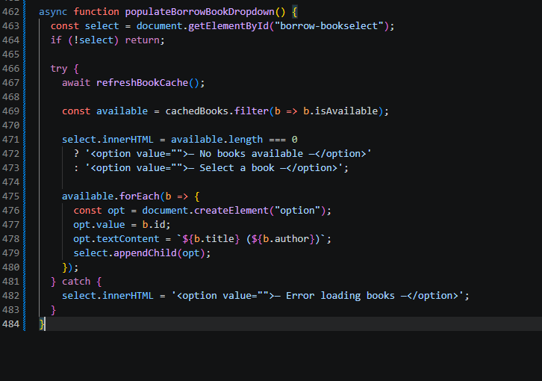

Part 14 — Populate Return Book Dropdown

Part-14-return-dropdown
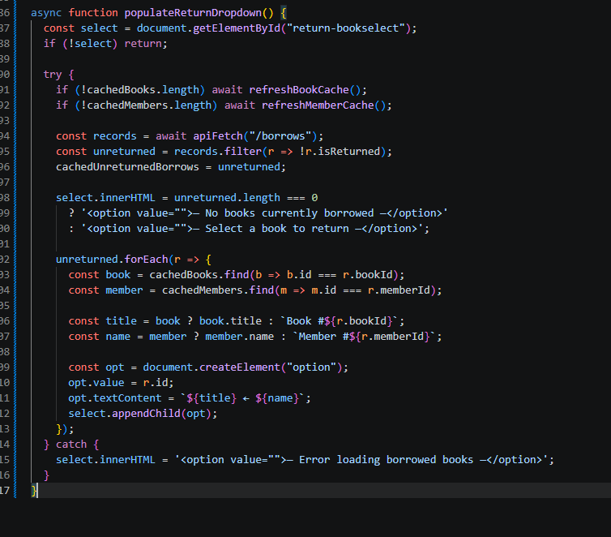

Part 15 — Borrow a Book

Part-15-borrow
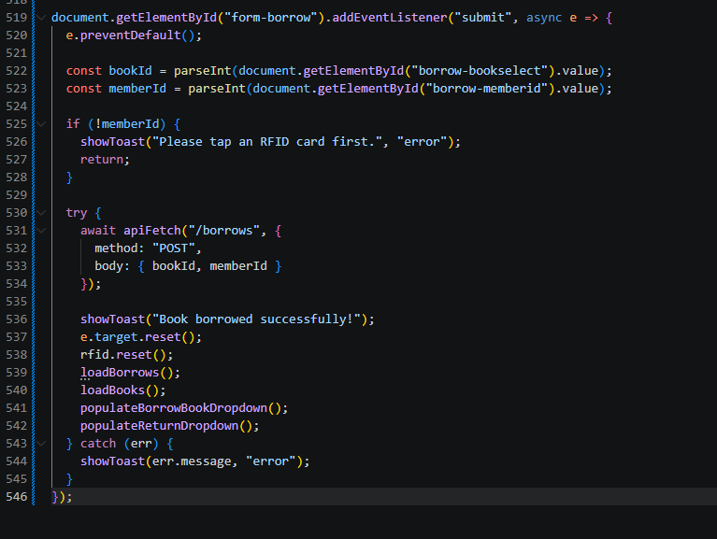

Part 16 — Return a Book

Part-16-return
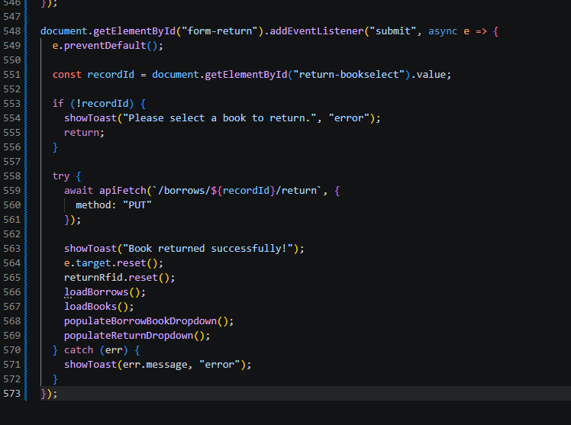

Part 17 — Load Borrow History Table

Part-17-loadborrows
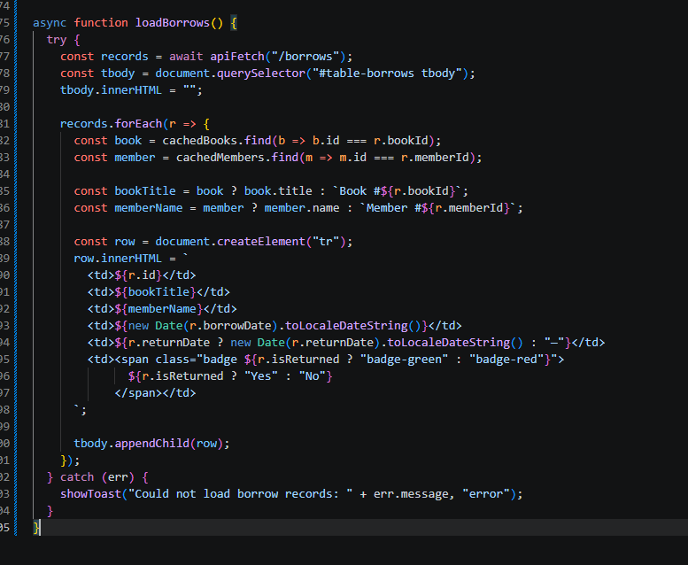

Part 18 — Initial Page Load

Part-18-page-load
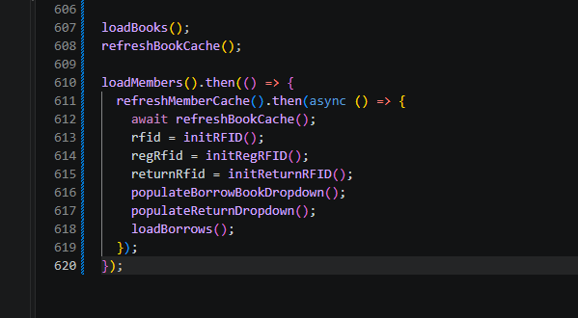

TESTING STEPS

1. Start the API
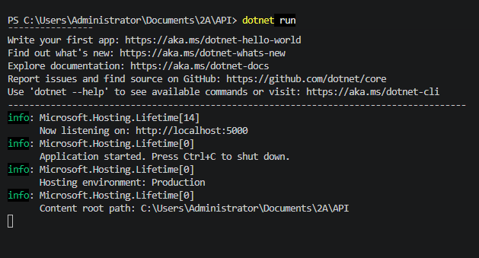

2. Open the FrontEnd
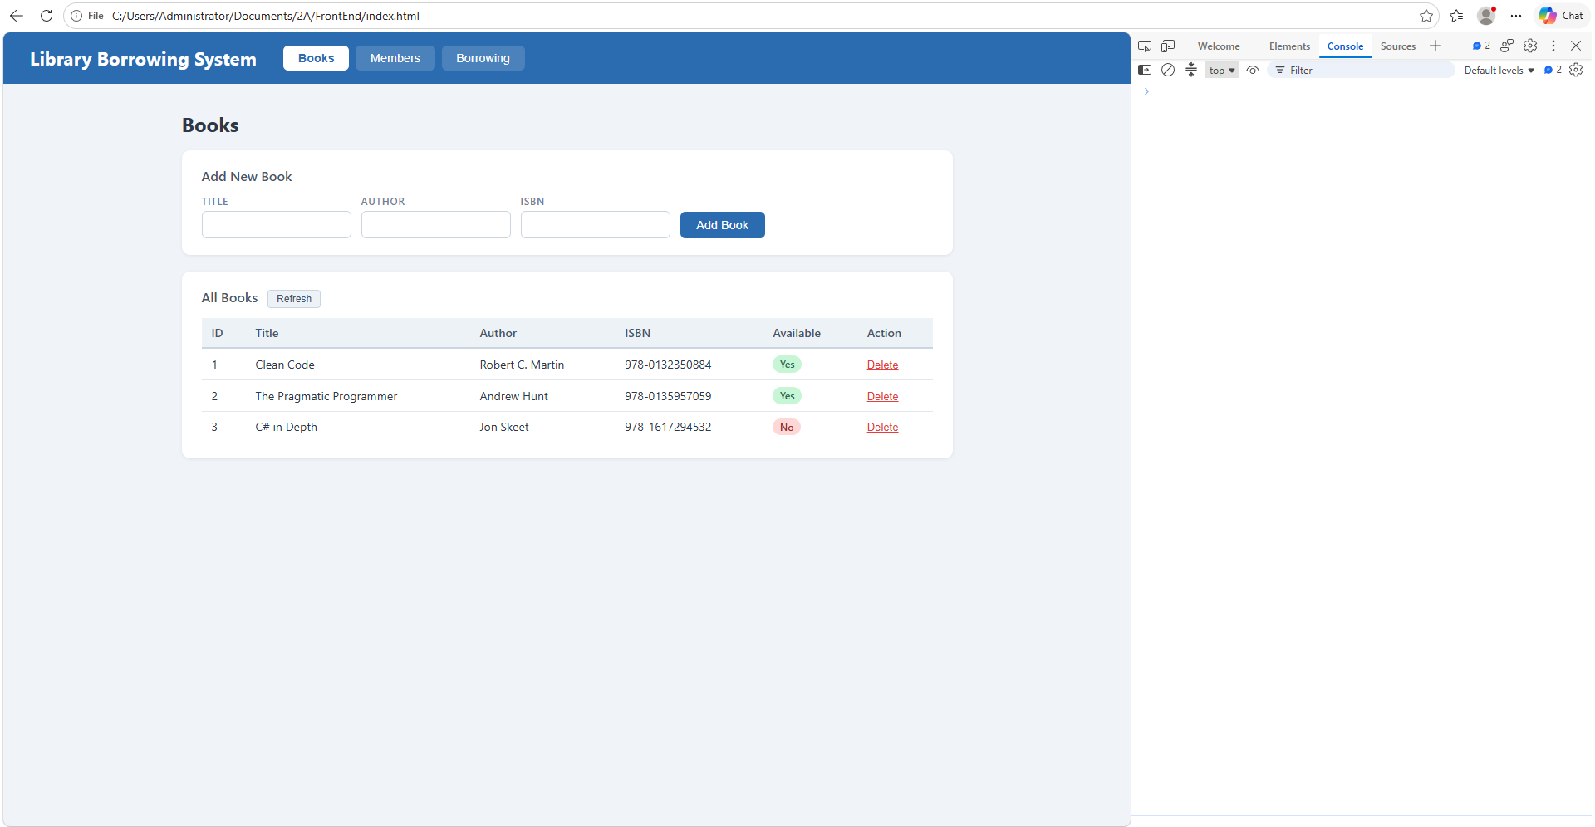

3. Test the Tabs
The tabs were already captured in early-03-tabs. No new screenshot here

4. Test Books
Add
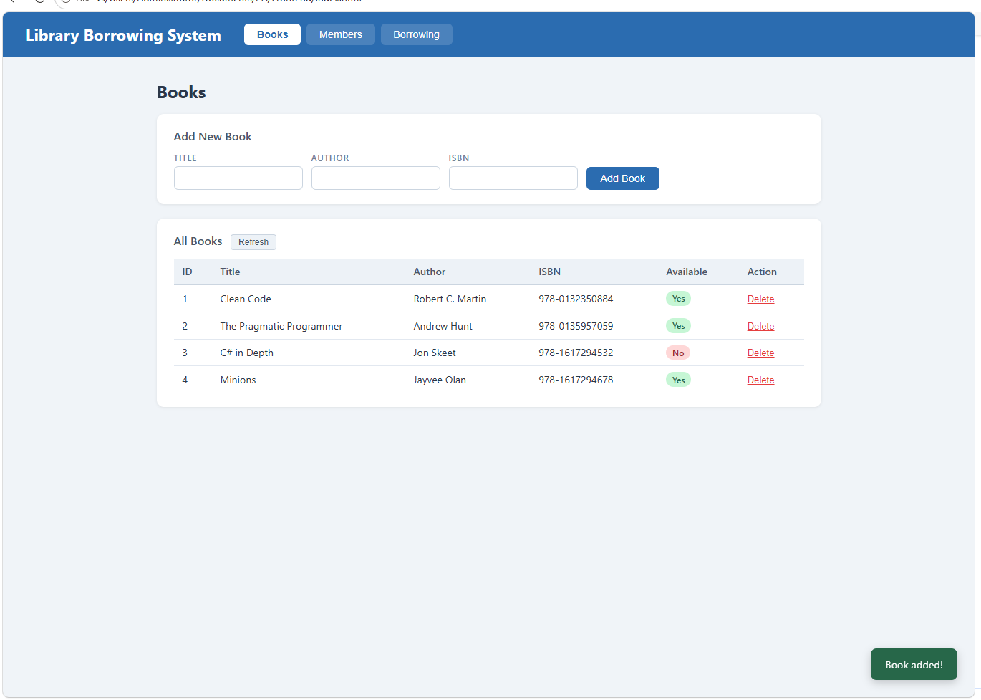

Delete
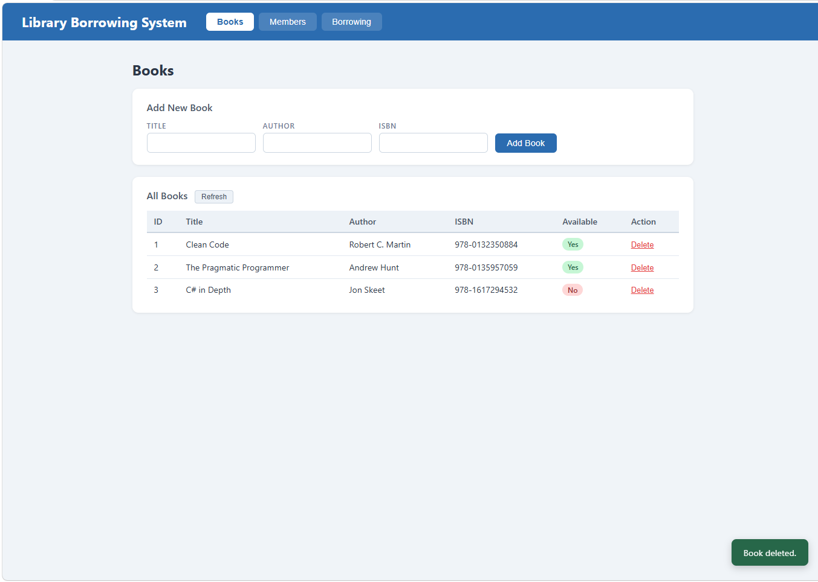

5. Test Members
test-04-members-loaded
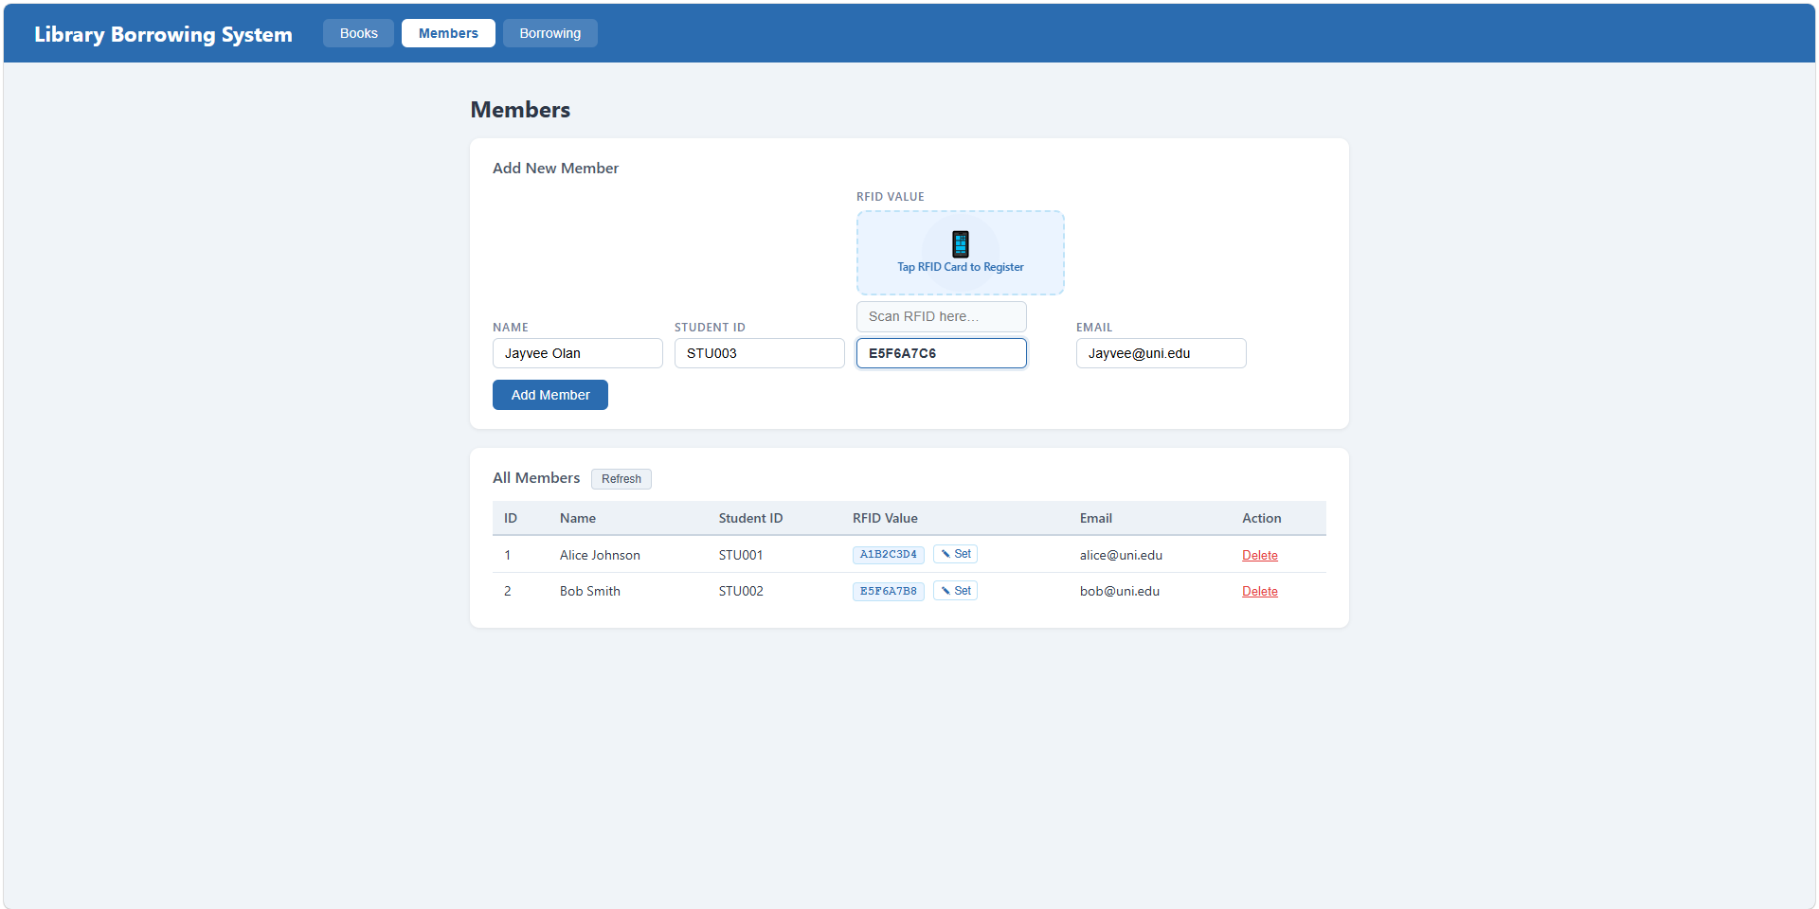
test-05-register-rfid
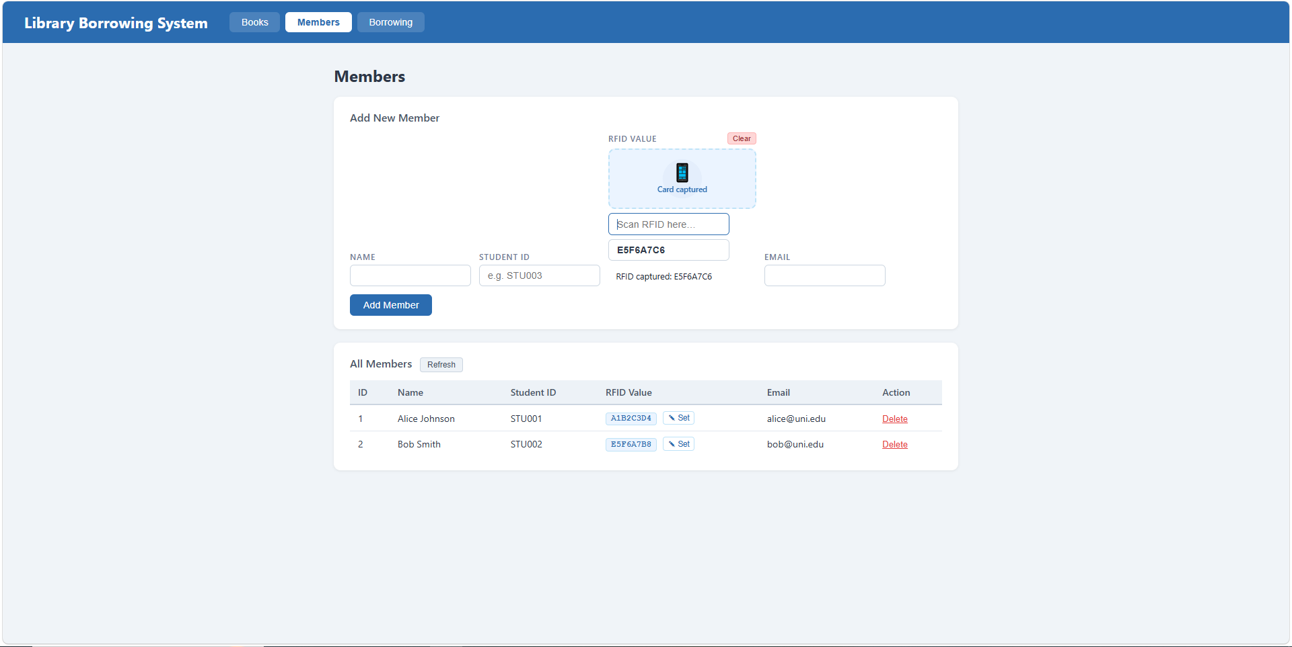

test-06-add-member
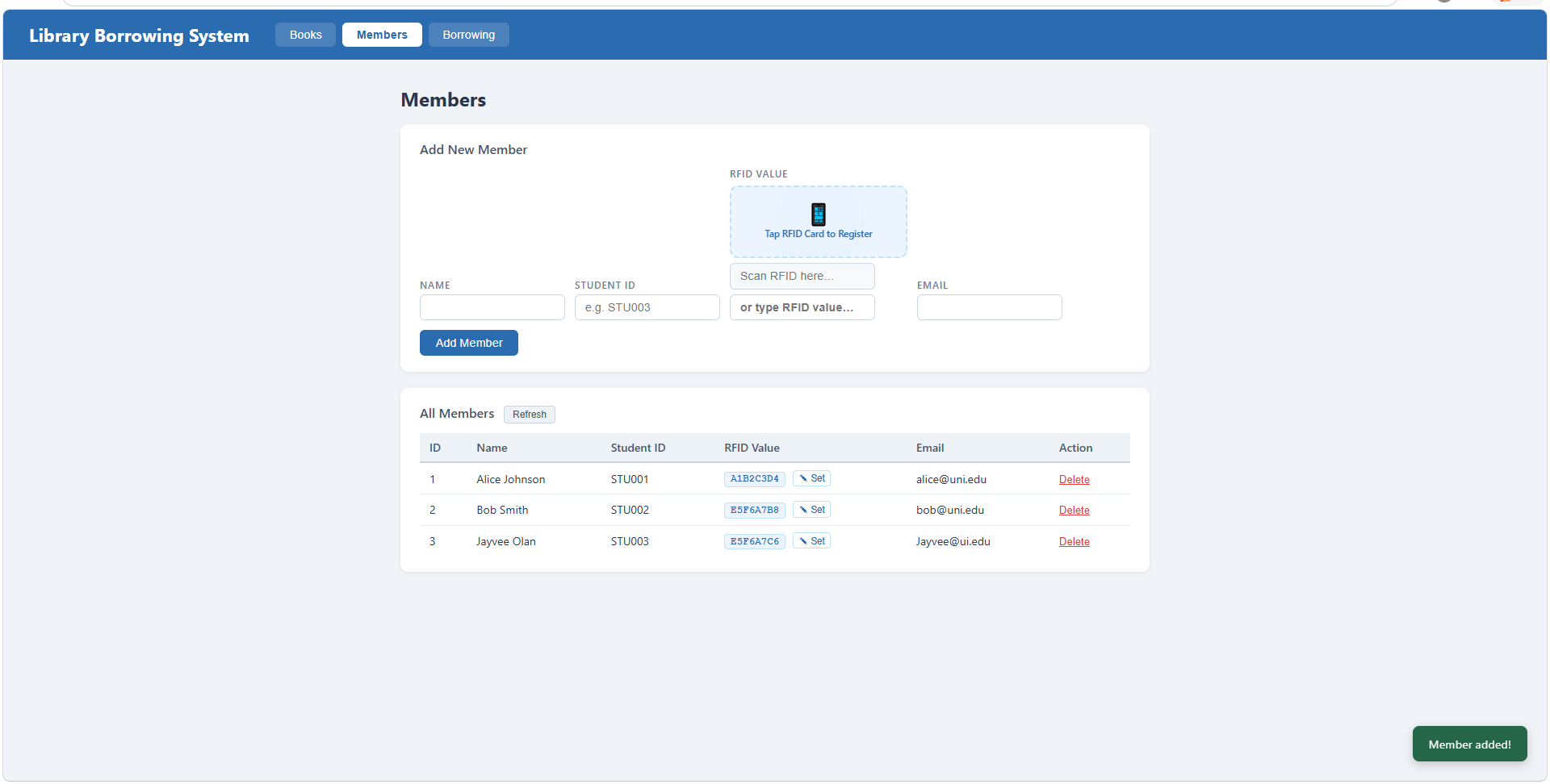
test-07-set-rfid-saved
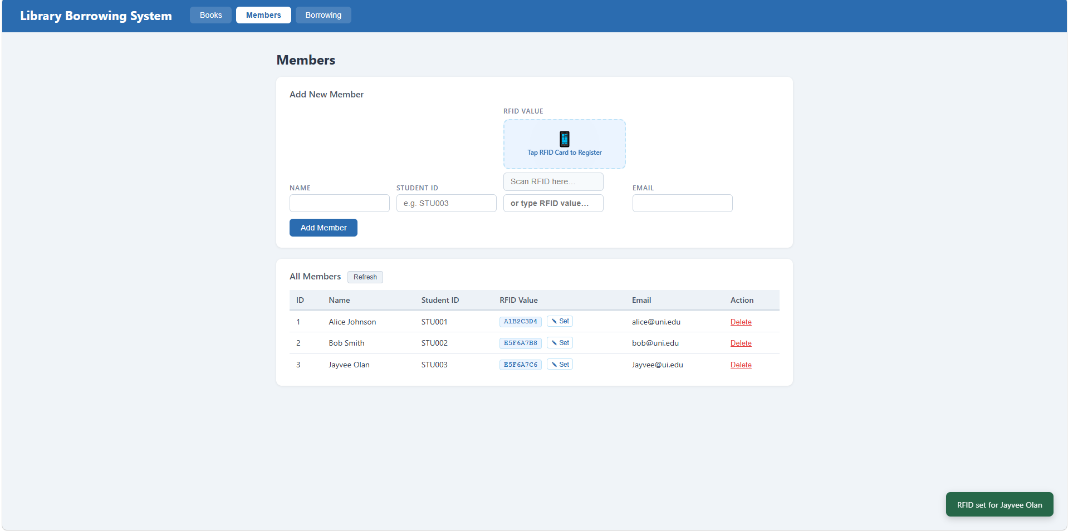

test-08-delete-member
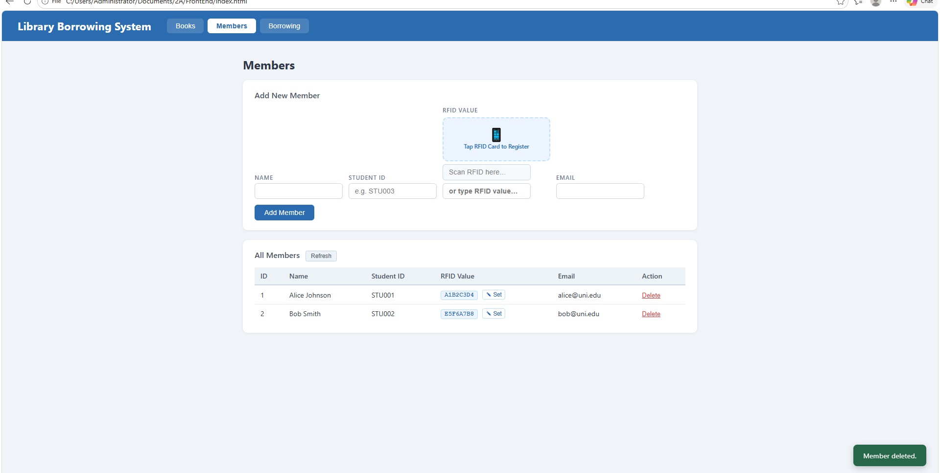

6. Test Borrowing
test-09-borrow-rfid-recognized
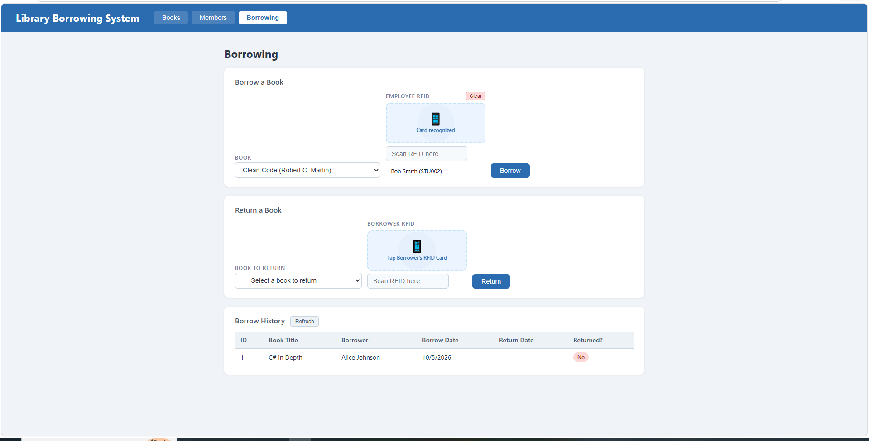

test-10-borrow-success
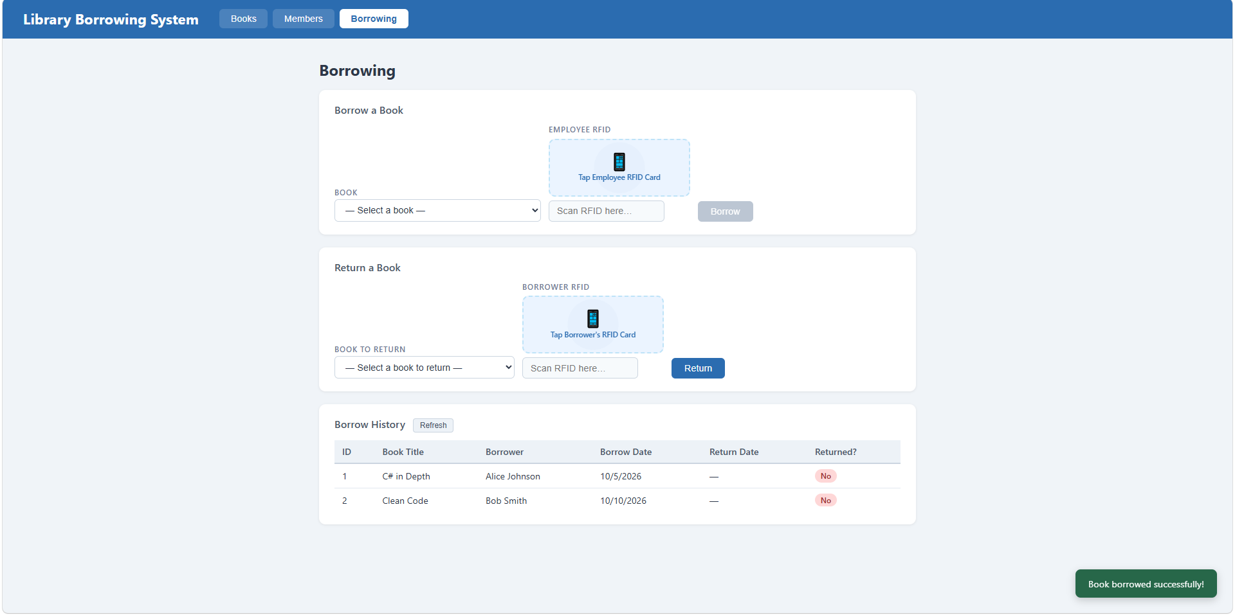

7. Test Returning
test-11-return-wrong-card
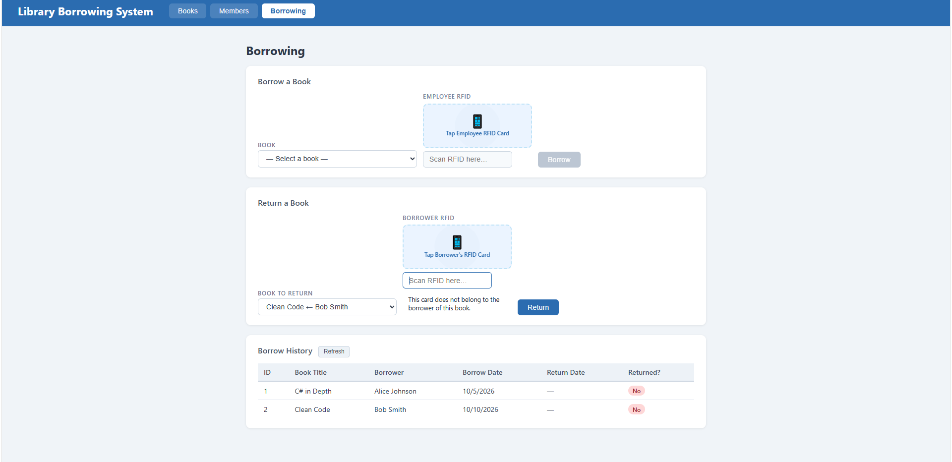
test-12-return-verified
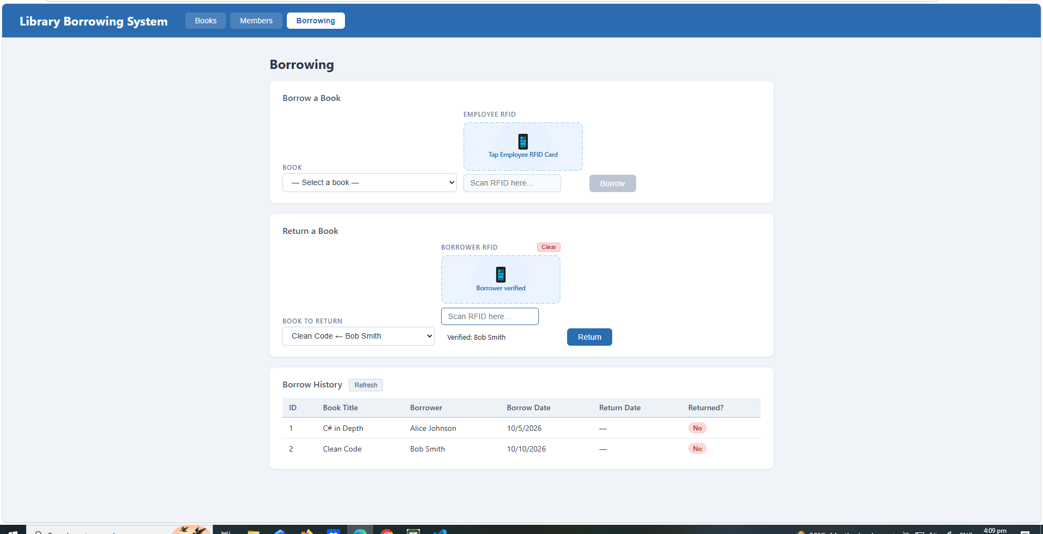

test-13-return-success
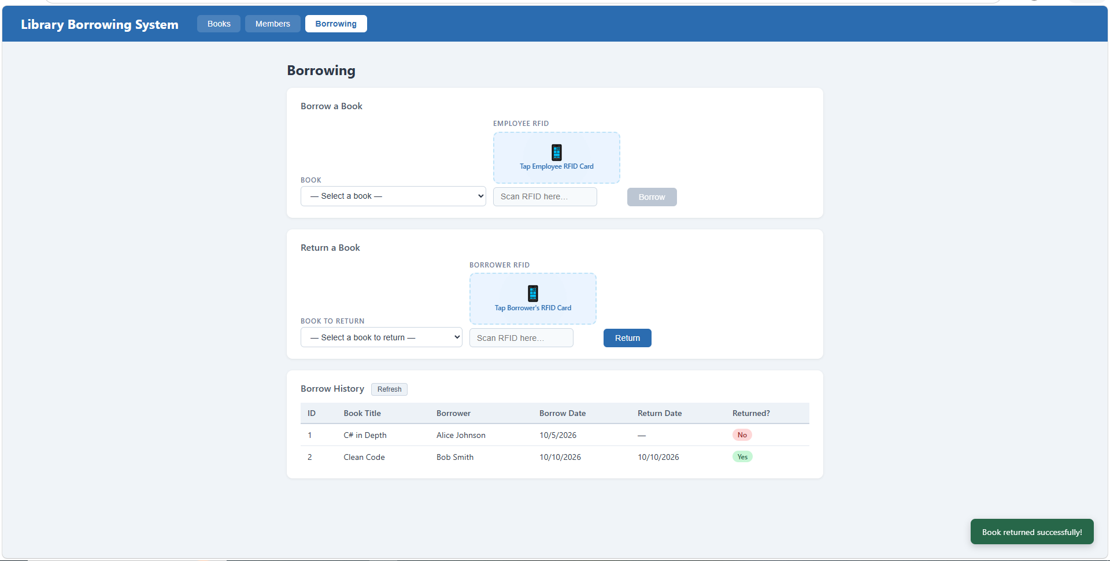

8. Final Console Check
test-14-final-console
